DB and TABLE CREATION:
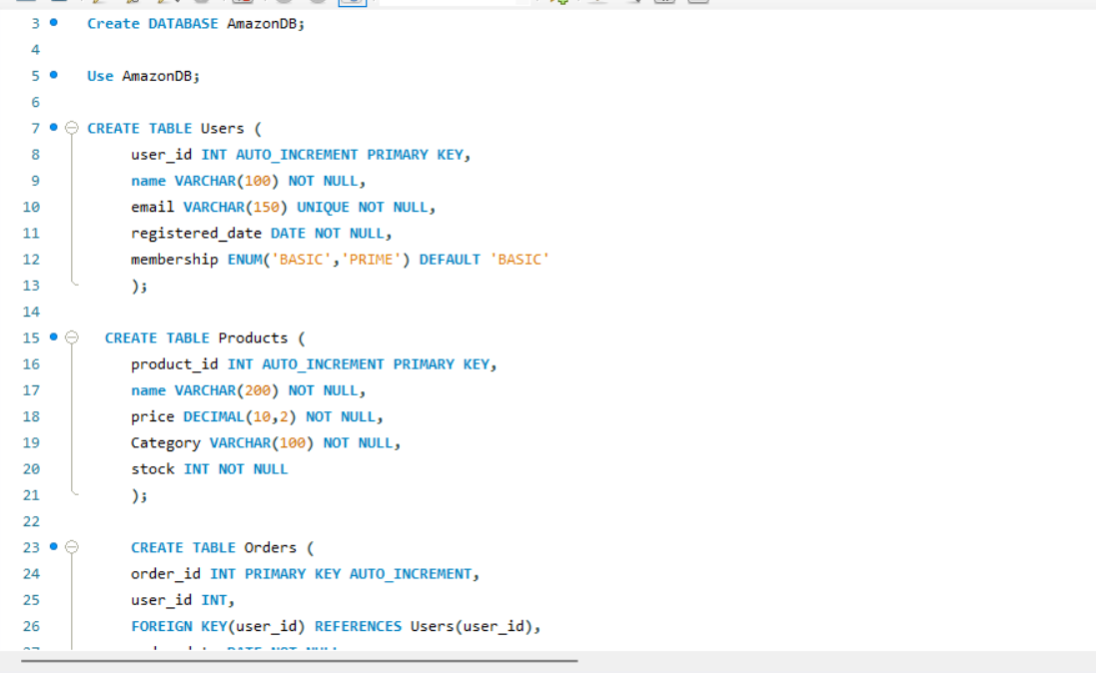
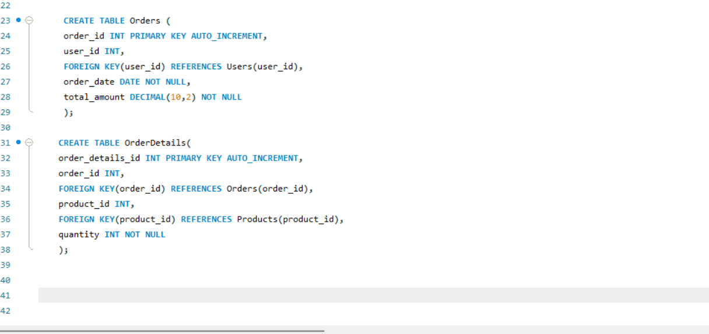

DATA INSERTION:
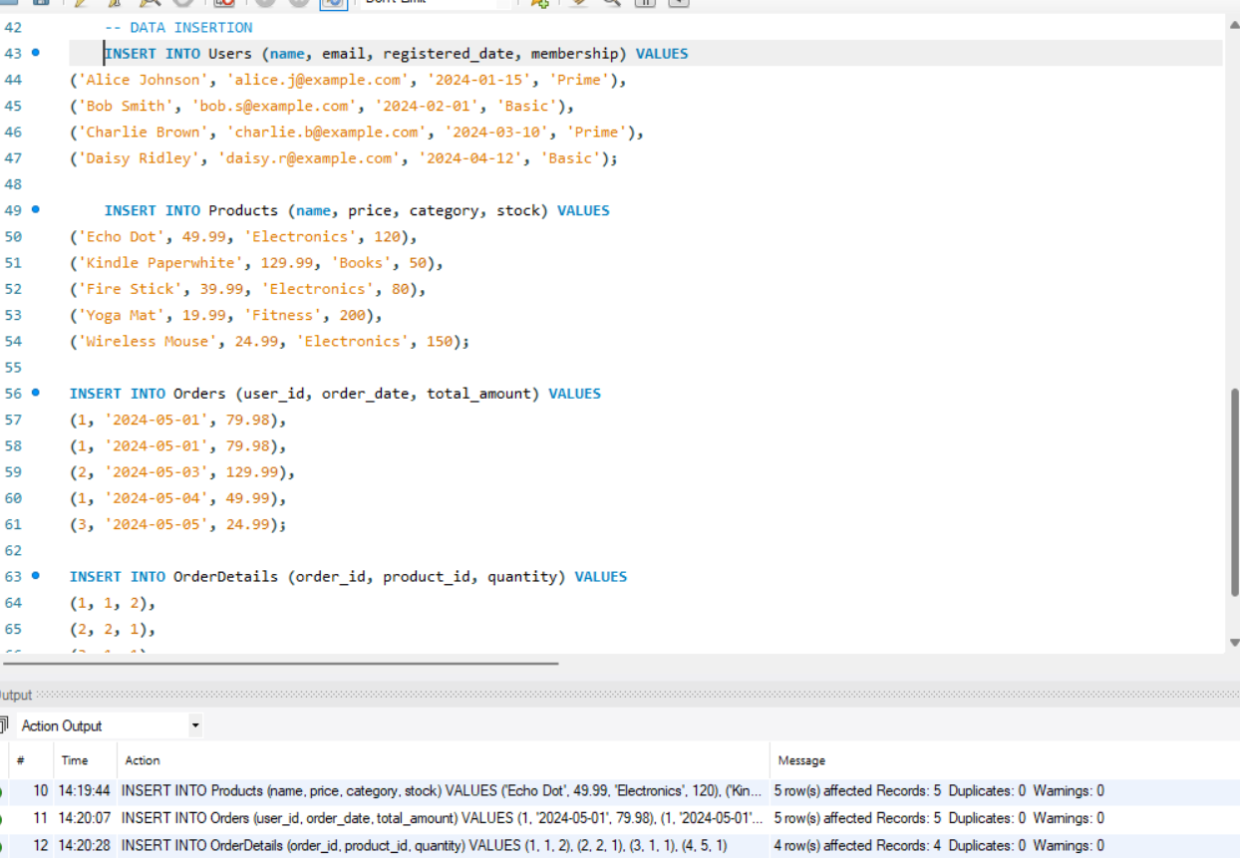

- List all customers who have made purchases of more than $80.
SELECT Users.name, Sum(Orders.total_amount) as total_spent
FROM Users INNER JOIN Orders
ON Users.user_id = Orders.user_id
Group by Users.user_id
Having total_spent >80;

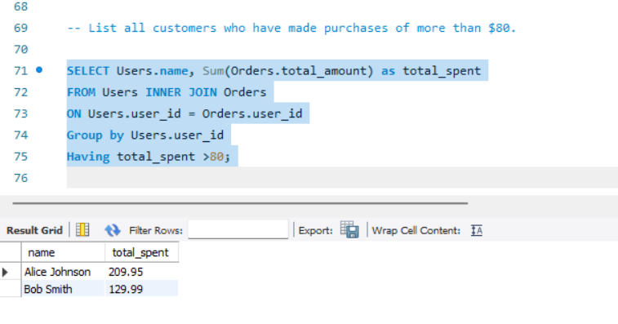
- Retrieve all orders placed in the last 280 days along with the customer name and email.

SELECT Orders.order_id, Users.name, Users.email
FROM Orders INNER JOIN Users
ON Orders.user_id = Users.user_id
WHERE Orders.order_date >= DATE_SUB(CURDATE(), INTERVAL 280 DAY);
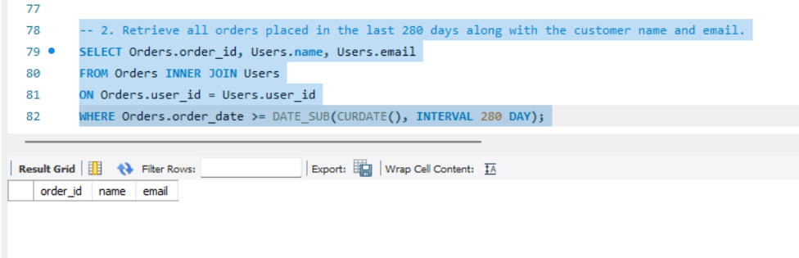

We don’t have orders placed on 280 days ago in the database, so we got null values.

3. Find the average product price for each category.
SELECT Category, avg(price) as avg_product_price
FROM Products
group by Category
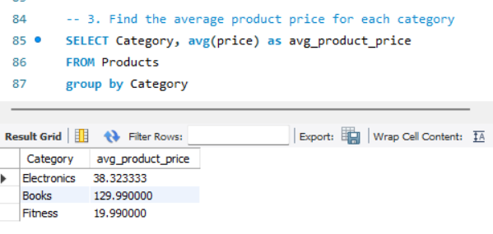

- List all customers who have purchased a product from the category Electronics.

SELECT DISTINCT Users.name, Users.email
FROM USERS JOIN Orders
ON Users.user_id = Orders.user_id
JOIN OrderDetails
ON Orders.Order_id = OrderDetails.Order_id
JOIN Products
ON OrderDetails.product_id = Products.product_id
WHERE Products.Category = "Electronics";

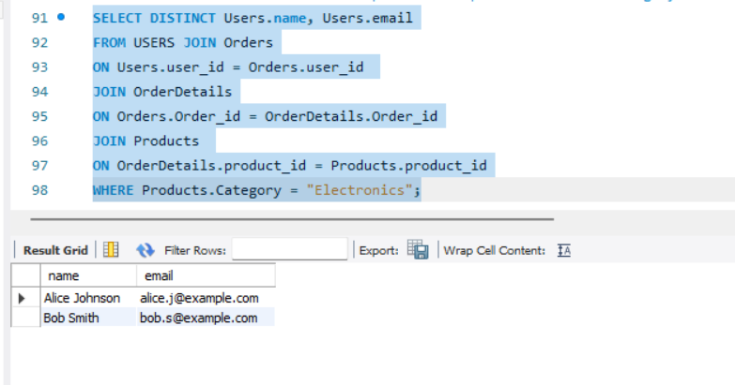

- Find the total number of products sold and the total revenue generated for each product

SELECT products.product_id, products.name, sum(quantity) as total_qty_sold, sum(quantity)*price as Total_revenue
FROM orderdetails JOIN products
ON orderdetails.product_id=products.product_id
Group BY product_id
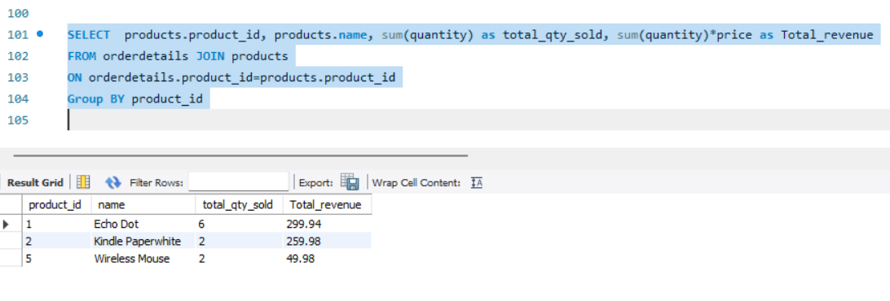

- Update the price of all products in the Books category, increasing it by 10%.
Current Price details:
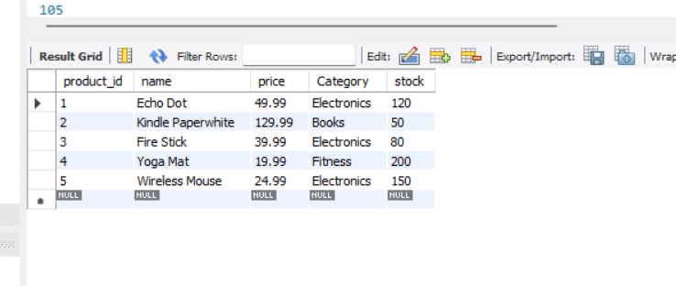
UPDATE PRODUCTS
SET price=price+0.1*price
WHERE Category="Books";

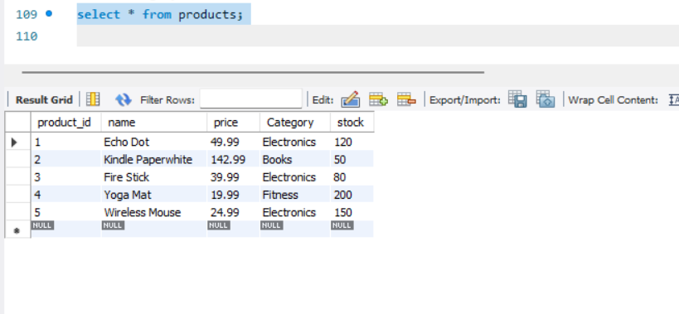

UPDATE PRODUCTS
SET price=price*1.10
WHERE Category="Books";
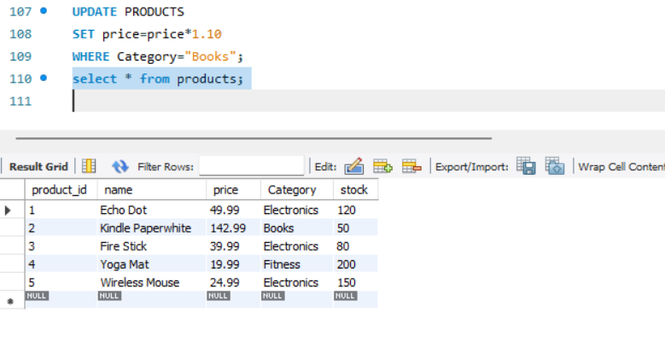

- Remove all orders that were placed before 2020.
We don’t have orders related to 2020, so no rows are deleted
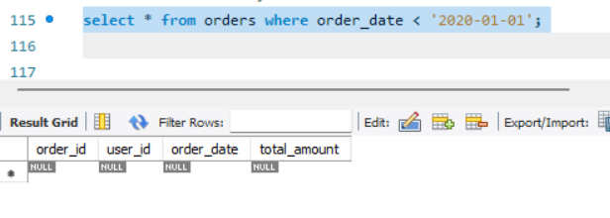

DELETE FROM orders where order_date < '2020-01-01';

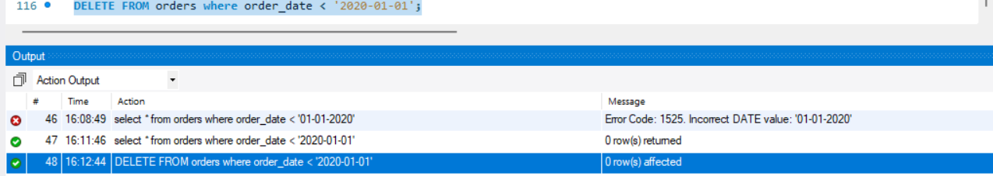

- Write a query to fetch the order details, including customer name, product name, and
quantity, for orders placed on 2024-05-01.
SELECT Users.name, Products.name, orderdetails.quantity from
orderdetails JOIN
products
ON orderdetails.product_id=products.product_id
JOIN orders
ON orderdetails.order_id = orders.order_id
JOIN users
ON orders.user_id = users.user_id
WHERE orders.order_date ='2024-05-01'

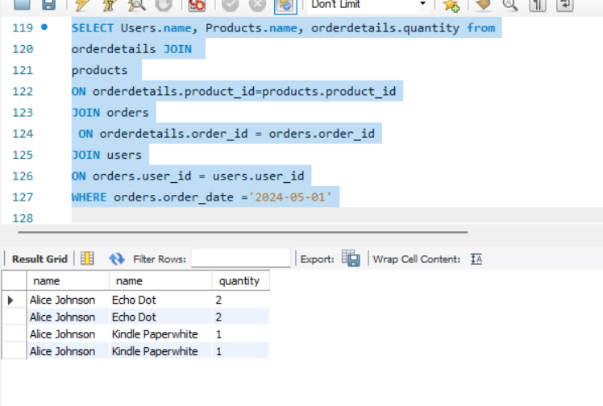

- Fetch all customers and the total number of orders they have placed.

SELECT users.name, count(order_id) as total_no_orders FROM
users LEFT JOIN orders
ON users.user_id = orders.user_id
group by users.user_id

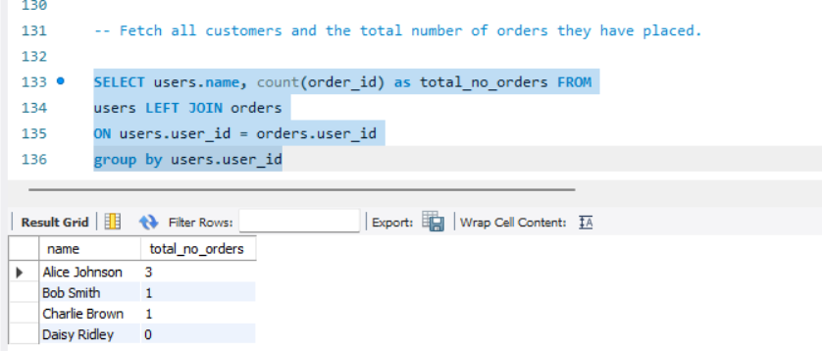

- List all customers who purchased more than 1 units of any product, including the product name and total quantity purchased

SELECT users.name, products.name, sum(orderdetails.quantity) as total_quantity
FROM users JOIN orders
ON users.user_id = orders.order_id
JOIN orderdetails
ON orders.order_id = orderdetails.order_id
JOIN products
ON orderdetails.product_id = products.product_id
GROUP BY users.user_id, orderdetails.product_id
having total_quantity > 1;

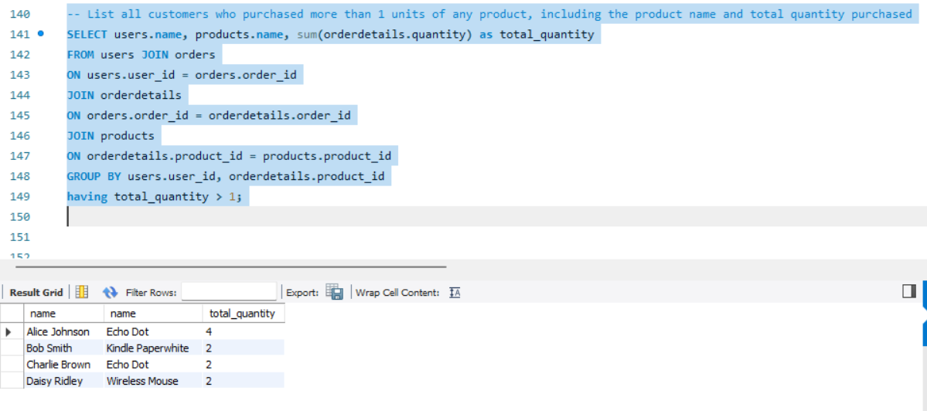

-- Find the total revenue generated by each category along with the category name

SELECT p.Category, sum(p.price*OD.quantity) as total_revenue
FROM products p JOIN
orderdetails OD
ON p.product_id=OD.product_id
GROUP BY p.product_id;
